MILITARY COLLEGE OF SIGNALS
NATIONAL UNIVERSITY OF SCIENCES & TECHNOLOGY


SOFTWARE CONSTRUCTION
SUBMITTED TO: LE AQSA
LAB | 08
SUBMISSION DATE | 10.27.2025
COURSE | BESE 29-B
SUBMITTED BY | AMNA NOOR

Static vs Dynamic binding:
Static Binding: Compile Time
Example #1:
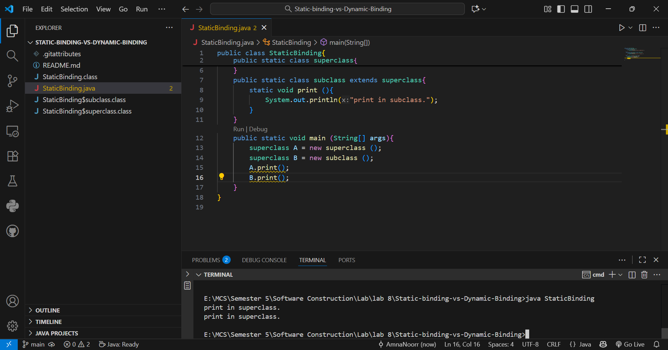
Example #2:
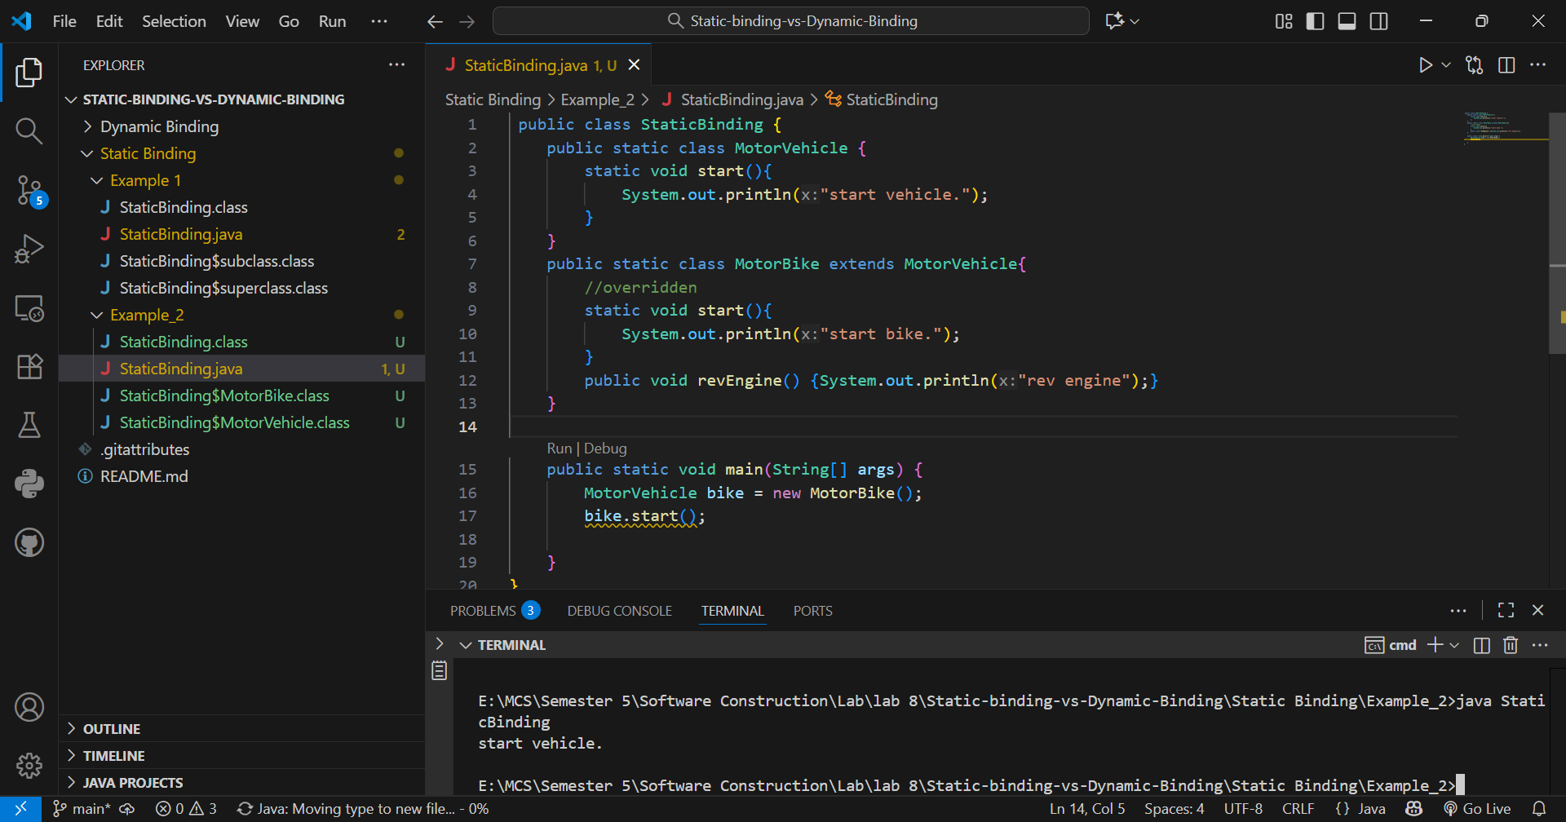
Example # 3
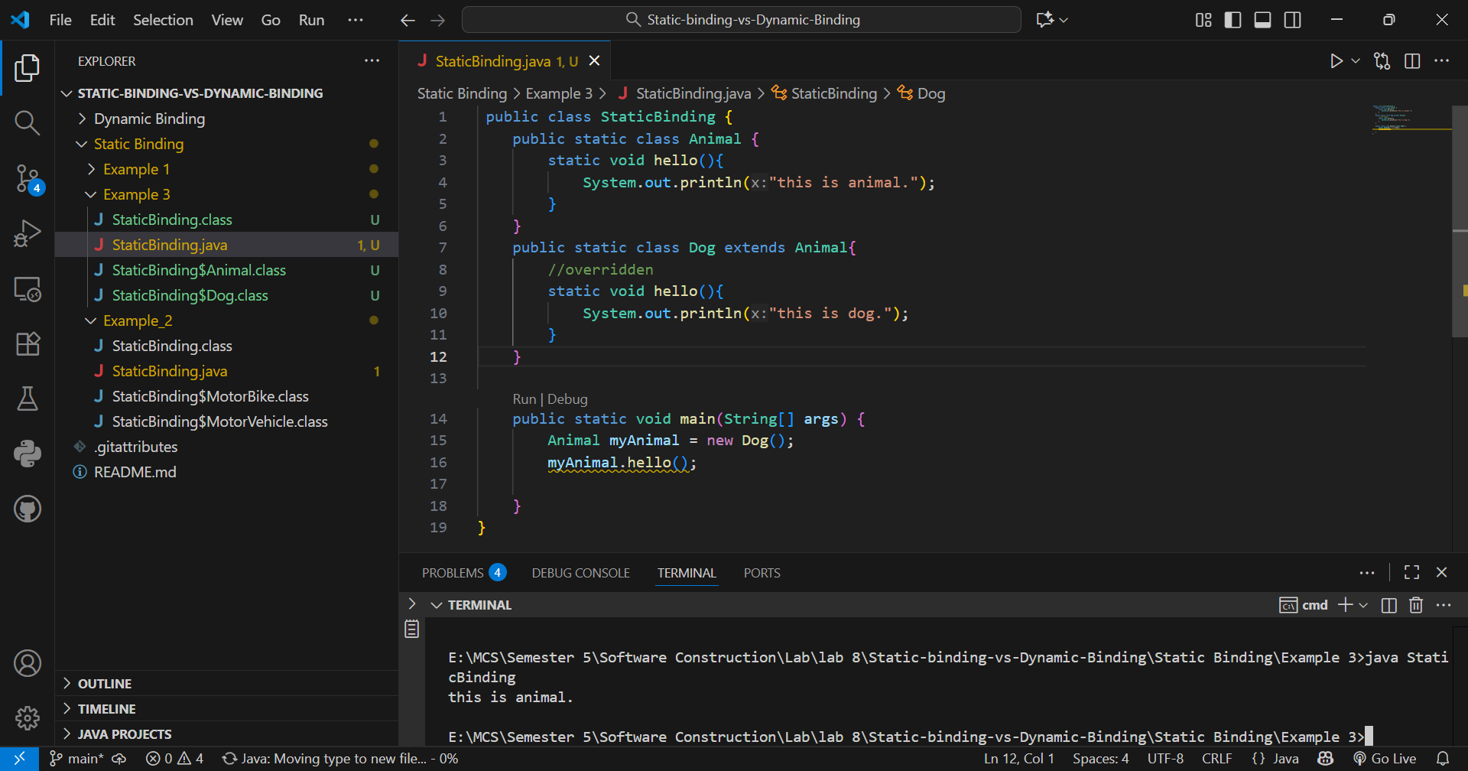

Dynamic Binding: Runtime
Example 1:
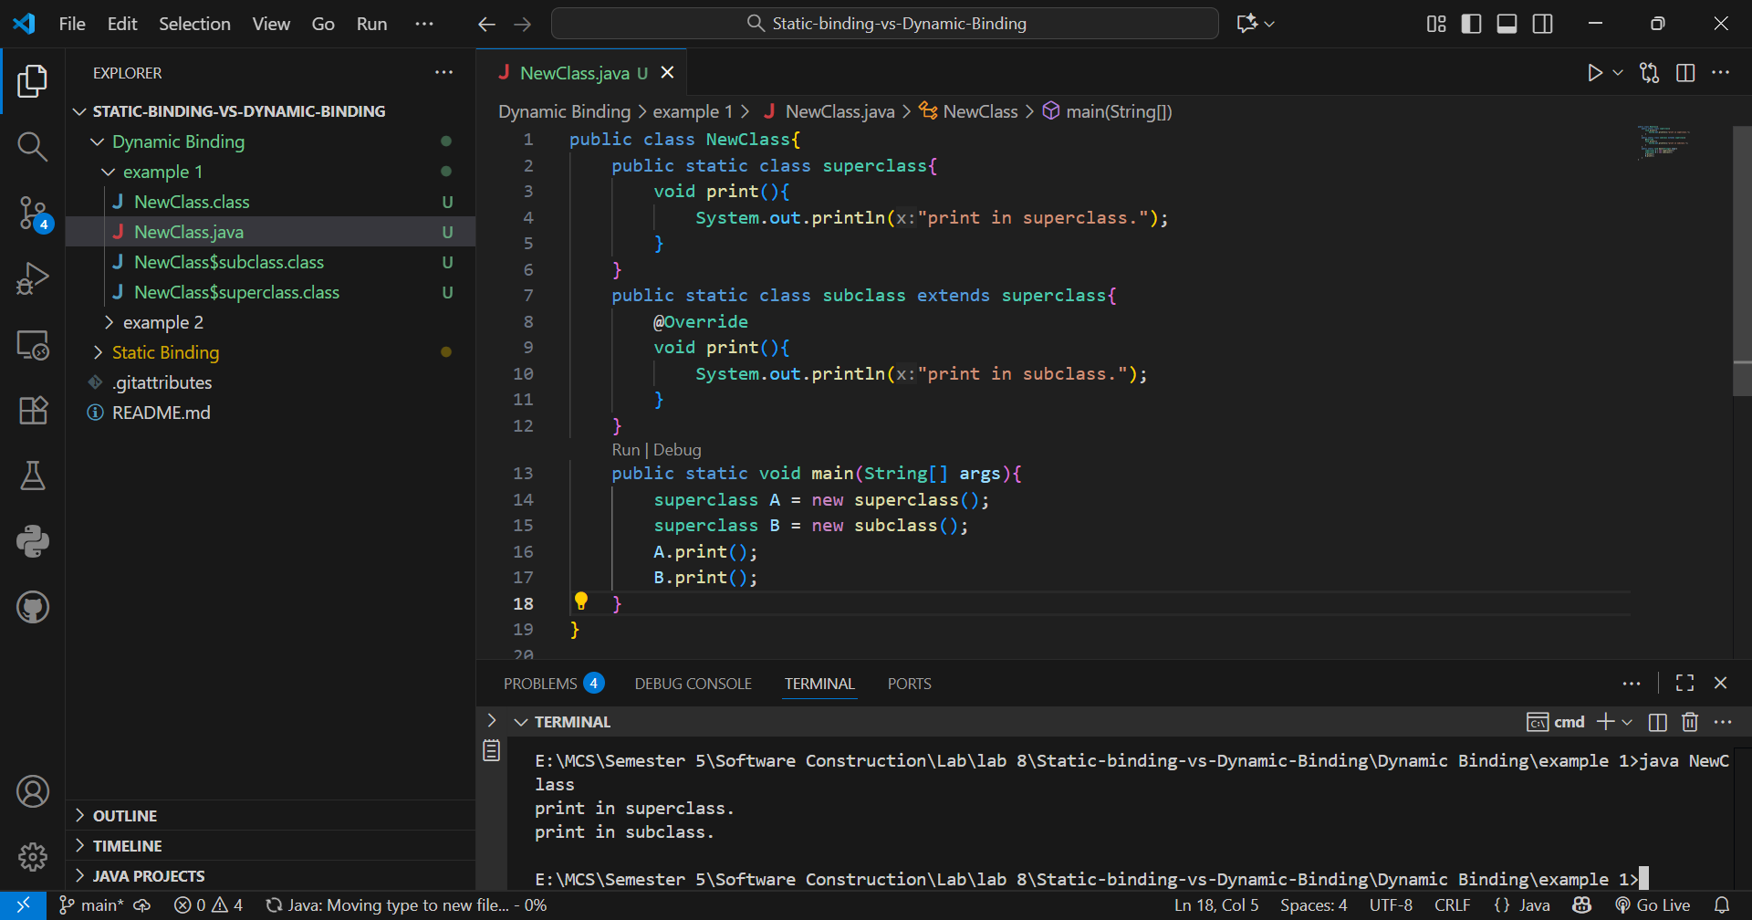
Example #2
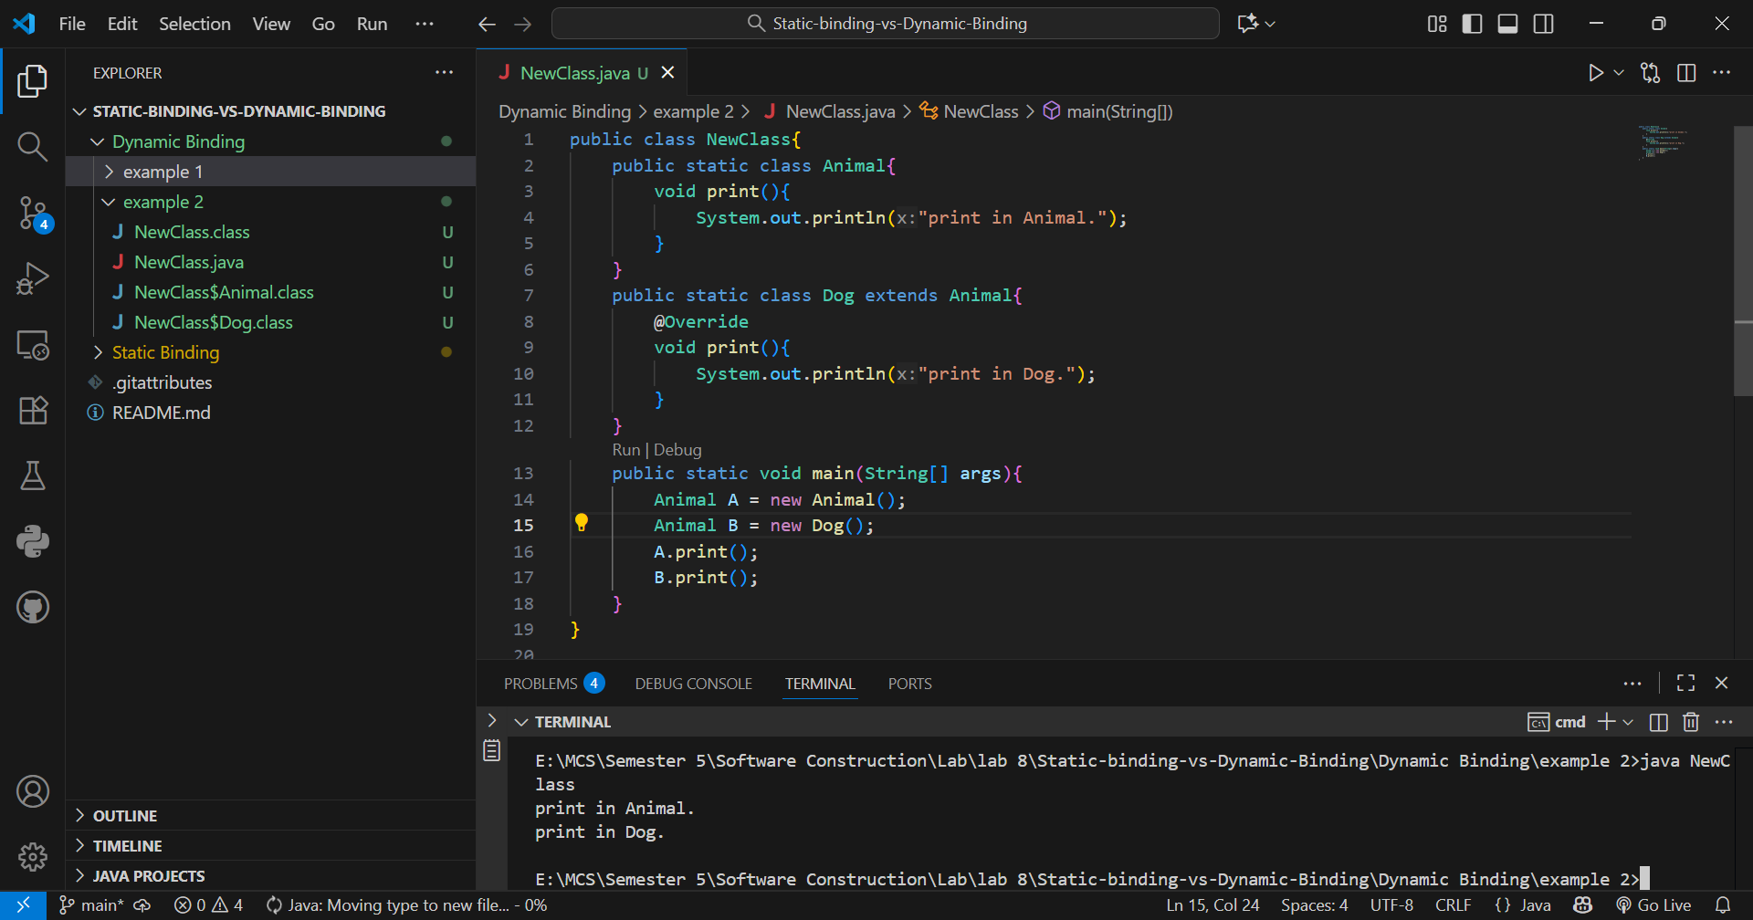
Example #3
